Component / Version - Product / Version Cross-reference Document

# Revision

Version 2

11/15/21 10:07 AM

# SME

Charles Wilson

Garth Scheidemantel

# Abstract

This document describes the process used to track software components currently in use so that they may be reused.

# Group / Owner

Development / Software Developer

# Motivation

This document is motivated by the need to track components determined to be secure so that they may be reused. This is necessary given the nature of safety-critical, cyber-physical systems, subject to certifications such as ISO 21434 and 26262.

# License

This work was created by **Motional** and is licensed under the **Creative Commons Attribution-Share Alike (CC4-SA)** License.

[**https://creativecommons.org/licenses/by/4.0/legalcode**](https://creativecommons.org/licenses/by/4.0/legalcode)

# Overview

Security-qualified component reuse lowers the costs of software development, expedites software development, and decreases the likelihood of introducing additional security vulnerabilities into the software. This is particularly true for software that implements security functionality, such as cryptographic modules and protocols.

The component / version – product / version cross-reference enables both rapid selection of currently in-use components, and determination of products impacted by issues discovered in these components.

Below is an overview of the process used to create and summarize the cross-reference.

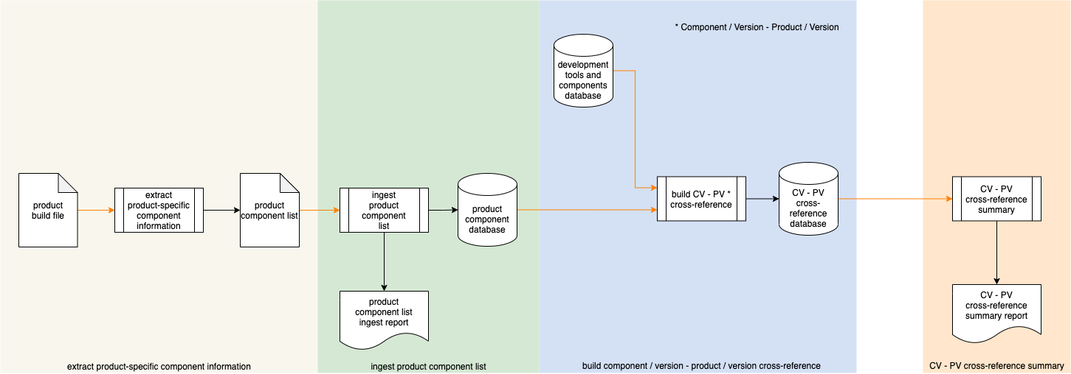

# Process

## Extract Product-specific Component Information

|  |  |
| --- | --- |
| **Inputs** | Product build file |
| **Outputs** | Product component list |
| **Participants** | **none** |

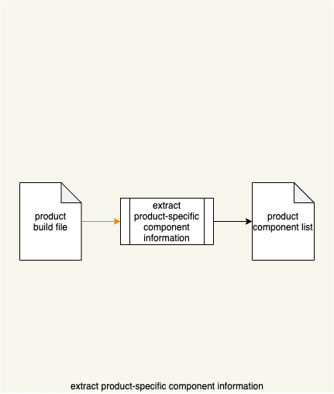

A **Product Build File** is analyzed, and a **Product Component List** produced.

## Ingest Product Component List

|  |  |
| --- | --- |
| **Inputs** | Product component list |
| **Outputs** | Product component database  Product component list ingest report |
| **Participants** | **none** |

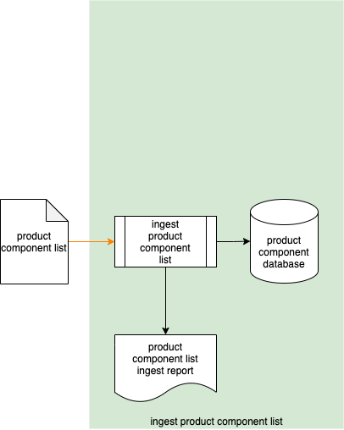

The **Product Component List** is ingested into the **Product Component Database**. A **Product Component List Ingest Report** is generated.

## Build Component / Version – Product / Version Cross-reference

|  |  |
| --- | --- |
| **Inputs** | Product component database  Development tools and components database |
| **Outputs** | Component / version – product / version cross-reference database |
| **Participants** | **none** |

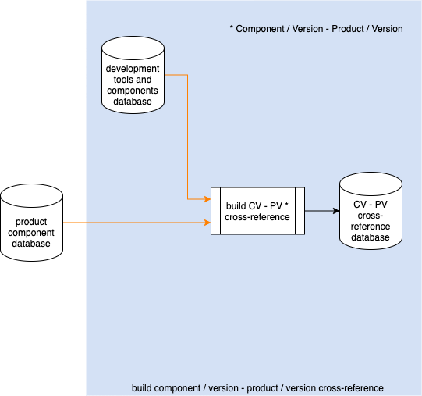

The **Product Component Database** is cross-referenced against the **Development Tools and Components Database** (see **List of Approved Tools [1]**) with the resulting information populating the **Component / Version – Product / Version Cross-reference Database**.

**Note:** The **Product Component Database** and **Development Tools** and **Components Database** will likely be represented as tables within the same database. The **Component / Version – Product / Version Cross-reference Database** will likely be a join between the two tables also residing in the same database.

**Note:** In practice, both the **Component / Version – Product / Version Cross-reference Database** will be referenced during the incident response process (see **Incident Response Plan [3]**).

## Component/Version – Product/Version Cross-reference Summary

|  |  |
| --- | --- |
| **Inputs** | Component / version – product / version cross-reference database |
| **Outputs** | Component / version – product / version cross-reference summary report |
| **Participants** | **none** |

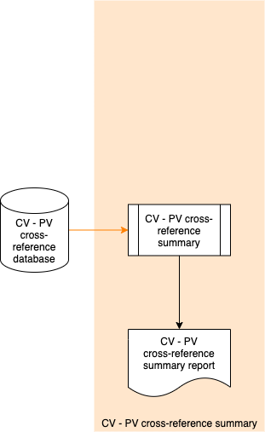

On a periodic basis, the **Component / Version – Product / Version Cross-reference Database** is queried, and a **Component / Version – Product / Version Cross-reference Summary Report** is generated.

**Note:** The generation of a summary is typically an auditing-related activity.

# References

1. **List of Approved Tools** (AVCDL secondary document)
2. **Product Component List Ingest Report** (AVCDL tertiary document)
3. **Incident Response Plan** (AVCDL secondary document)
4. **Cybersecurity Monitoring Plan** (AVCDL secondary document)
5. **Component / Version – Product / Version Cross-reference Summary Report** (AVCDL tertiary document)